**PROGRAMMING IN JAVA LAB-2**

**//**

**PRN-21070126033**

**Name- Harsh Tripathi**

**Batch-AIML A2**

**Program Description: Part1: Write a Java program that declares two arrays named ‘even’ and ‘odd’. Accept numbers from the user and move them to respective arrays depending on whether they are even or odd.  
Part2: Implement a java function that finds 2 neighbouring numbers in an array with the smallest distance to each. The function should return the index of the 1st number.  
Part 3: Write a Java program to convert an array into ArrayList and vice versa.**

**//**

// Create a Java Program that takes accepts numbers from users and stores them in two different arrays, odd and even.

import java.util.*;

import java.util.Scanner;

class Smallest_distance

{

static void smallest_distance()

{

int[] arr = new int[10];

Scanner sc = new Scanner(System.in);

System.out.println("Enter 10 numbers: ");

for (int i = 0; i < 10; i++) {

arr[i] = sc.nextInt();

}

int min = Integer.MAX_VALUE;

int minI=0,minJ=0;

for (int i = 0; i < 9; i++) {

int diff = arr[i+1] - arr[i];

if(diff < min){

min = diff;

minI = i;

minJ = i+1;

}

}

System.out.println("The smallest distance is between " + arr[minI] + " and " + arr[minJ]+ " and the distance is " + min);

sc.close();

}

}

class Array_List{

static void arraylist()

{

int[] array = new int[10];

Scanner sc = new Scanner(System.in);

System.out.println("Enter 10 numbers: ");

for(int l = 0; l < 10; l++)

{

int n = sc.nextInt();

array[l] = n;

}

ArrayList<Integer> list = new ArrayList<Integer>();

for(int l = 0; l < 10; l++){

list.add(array[l]);

}

System.out.println(list);

sc.close();

}

}

public class ArrayEvenOdd

{

public static void main(String[] args) {

System.out.println("1. Smallest distance between two numbers in an array");

System.out.println("2. Array to ArrayList");

System.out.println("3. Even and Odd numbers");

System.out.println("Enter your choice: ");

Scanner sc1 = new Scanner(System.in);

int choice = sc1.nextInt();

switch(choice)

{

case 1:

Smallest_distance.smallest_distance();

break;

case 2:

Array_List.arraylist();

break;

case 3:

// Create two arrays odd and even

int[] odd = new int[10];

int[] even = new int[10];

Scanner sc = new Scanner(System.in);

System.out.print("Enter numbers to classify, enter 'end' to stop: ");

while(true)

{

String input = sc.nextLine();

if(input.equals("end"))

{

break;

}

else

{

int num = Integer.parseInt(input);

if(num%2 == 0)

{

for(int i=0; i<even.length; i++)

{

if(even[i] == 0)

{

even[i] = num;

break;

}

}

}

else

{

for(int i=0; i<odd.length; i++)

{

if(odd[i] == 0)

{

odd[i] = num;

break;

}

}

}

}

}

sc.close();

// Print the arrays

System.out.println("Even numbers: ");

for(int i=0; i<even.length; i++)

{

if(even[i] != 0)

{

System.out.print(even[i]+" ");

}

}

System.out.println();

System.out.println("Odd numbers: ");

for(int i=0; i<odd.length; i++)

{

if(odd[i] != 0)

{

System.out.print(odd[i]+" ");

}

}

default:

System.out.println("Invalid choice");

}

sc1.close();

}

}

**OUTPUT**

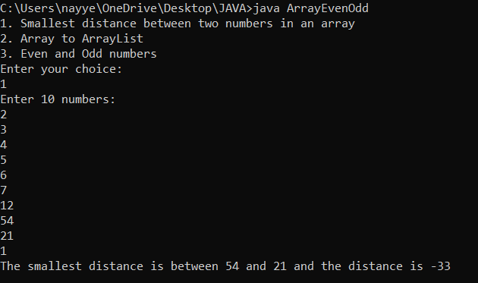

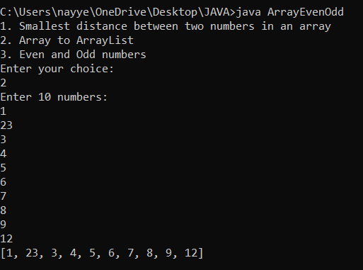

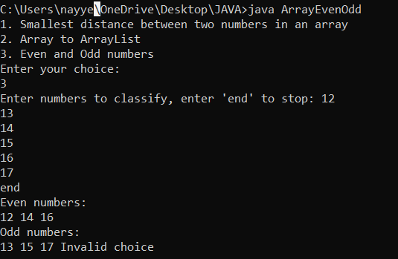

**GITHUB LINK: https://github.com/aadarsh1810/JAVA-SEM-4/tree/main/Assignment-2**